de Gucena 2018-01875

Feature Activity 03 Documentation

Getting setup

Creating a Dockerfile

Building the Dockerfile

Optimizing the Dockerfile

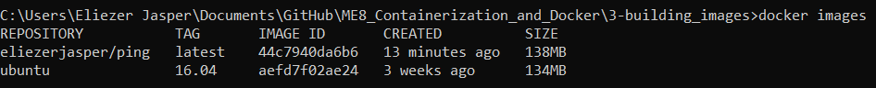

Other Dockerfile directives

